NAME - SHRESTHA DEY
SupersetID - 7719638
DN-5.0 JavaFSE Solutions

WEEK-1 : PL/SQL
EXERCISE 1: SETTING UP JUNIT
Scenario:
You need to set up JUnit in your Java project to start writing unit tests.
Steps:
- Create a new Java project in your IDE (VS Code, Eclipse, or IntelliJ IDEA).
- Add the JUnit dependency to the project.
- Create a Java class to be tested.
- Create a test class using JUnit.
- Run the test case and verify the output.
JUnit Dependency (pom.xml):
<dependency>
<groupId>junit</groupId>
<artifactId>junit</artifactId>
<version>4.13.2</version>
<scope>test</scope>
</dependency>

Solution Code:
Calculator.java
public class Calculator {
public static int add(int a, int b)
{
return a+b;
}
public int diff(int a,int b){
return a-b;
}
}
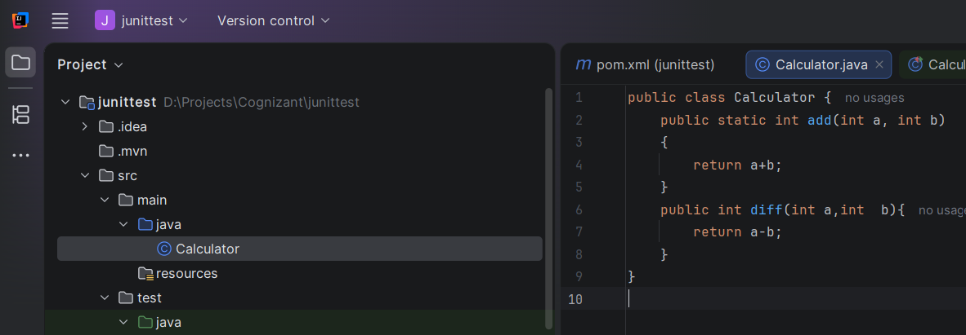
CalculatorTest.java
import org.junit.Test;
import static org.junit.Assert.assertEquals;
public class CalculatorTest {
@Test
public void testAdd() {
assertEquals(15, Calculator.add(10, 5));
}
@Test
public void testDiff() {
Calculator c = new Calculator();
assertEquals(5, c.diff(10, 5));
}
}
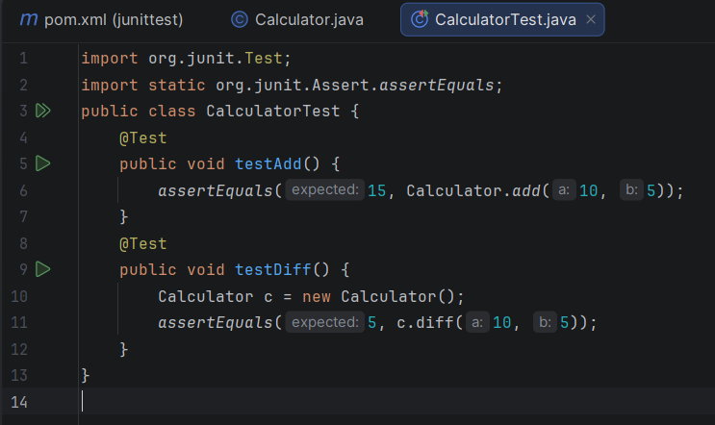

OUTPUT:
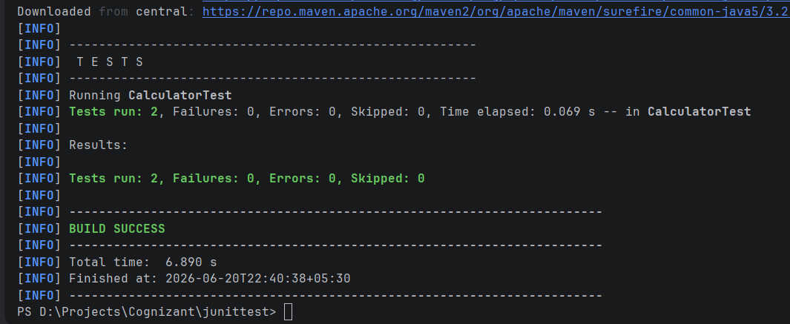

EXERCISE 3: ASSERTIONS IN JUNIT
Scenario:
You need to use different assertions in JUnit to validate your test results.

Steps:
- Create a test class named AssertionsTest.
- Import JUnit assertions.
- Write test cases using different assertion methods such as assertEquals(), assertTrue(), assertFalse(), assertNull(), and assertNotNull().
- Execute the test using Maven or your IDE.
Solution Code:
AssertionsTest.java
package com.example;
import org.junit.Test;
import static org.junit.Assert.*;
public class AssertionsTest {
@Test
public void testAssertions() {
assertEquals(5, 2 + 3);
assertTrue(5 > 3);
assertFalse(5 < 3);
assertNull(null);
assertNotNull(new Object());
}
}
OUTPUT:
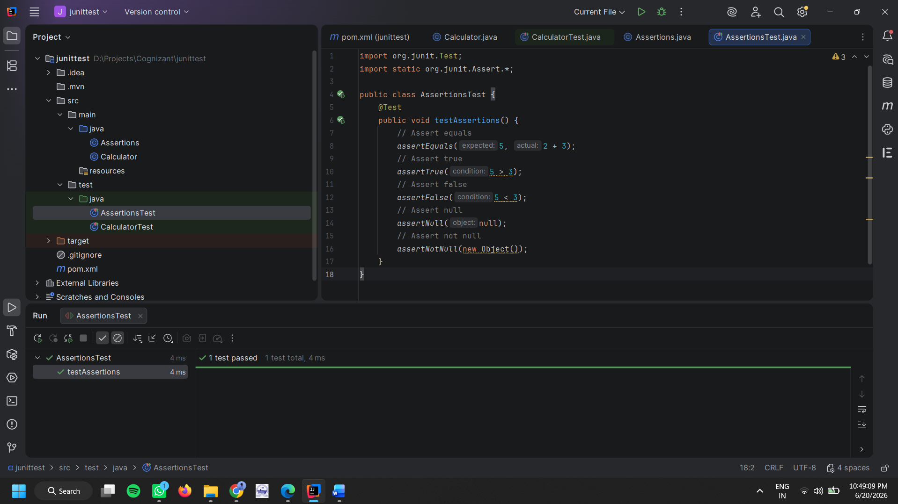

EXERCISE 4: ARRANGE-ACT-ASSERT (AAA) PATTERN, TEST FIXTURES, SETUP AND TEARDOWN METHODS IN JUNIT
Scenario
You need to organize your tests using the Arrange-Act-Assert (AAA) pattern and use setup and teardown methods.
Steps:
- Create a BankAccount class with basic operations:
  - deposit()
  - withdraw()
- Create a JUnit test class.
- Use @Before method to initialize the account before every test.
- Use @After method to clean up after every test.
- Write test cases using AAA pattern:
  - Arrange → prepare input
  - Act → call method
  - Assert → verify result
Solution Code:
BankAccount.java
public class BankAccount {
private int balance = 0;

public void deposit(int amount) {
balance += amount;
}

public void withdraw(int amount) {
balance -= amount;
}

public int getBalance() {
return balance;
}
}
BankAccountTest.java (JUnit Test)
import org.junit.Before;
import org.junit.After;
import org.junit.Test;
import static org.junit.Assert.*;
public class BankAccountTest {
BankAccount account;
@Before
public void setUp() {
account = new BankAccount();
System.out.println("Setup: Account created");
}
@After
public void tearDown() {
account = null;
System.out.println("Teardown: Account cleared");
}
@Test
public void testDeposit() {
int amount = 500;
account.deposit(amount);

assertEquals(500, account.getBalance());
}
@Test
public void testWithdraw() {
account.deposit(1000);
int withdrawAmount = 300;
account.withdraw(withdrawAmount);
assertEquals(700, account.getBalance());
}
}
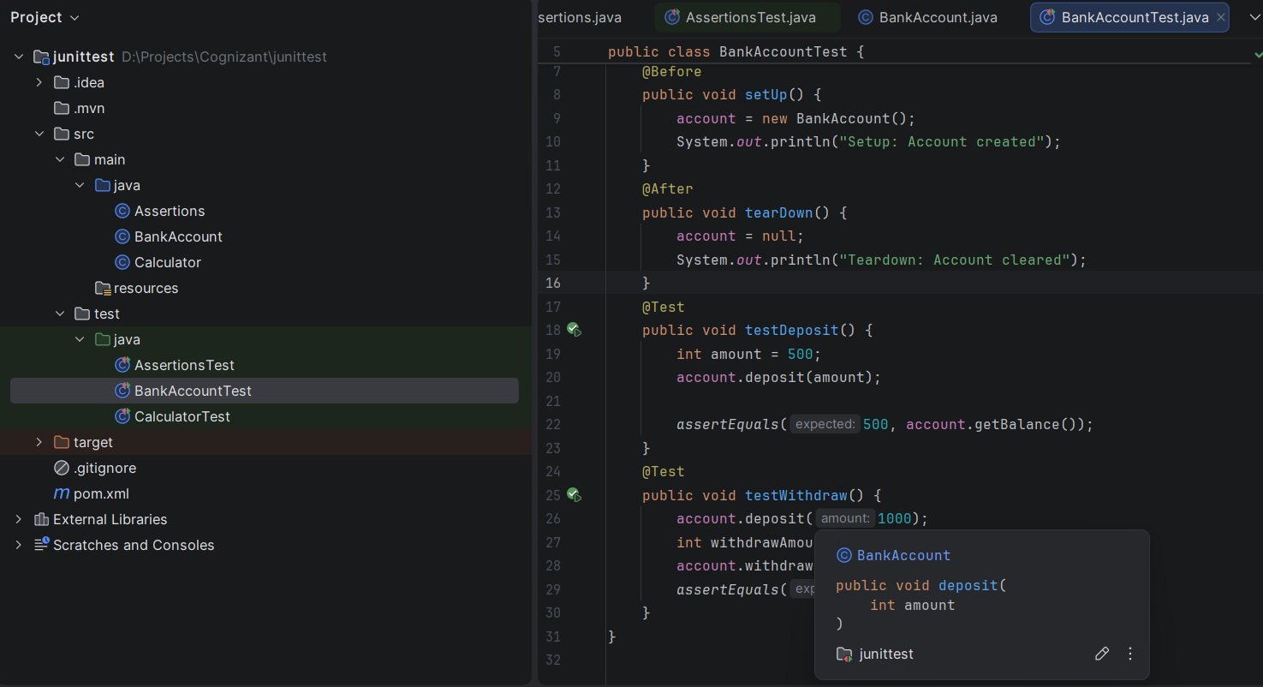
Output:
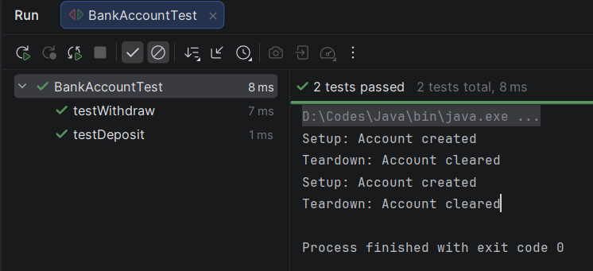

MOCKITO HANDS-ON EXERCISES

EXERCISE 1: MOCKING AND STUBBING
Scenario:
You need to test a service that depends on an external API. Use Mockito to mock the external API and stub its methods.

Steps:
1. Create a mock object for the external API.
2. Stub the method to return a predefined value.
3. Inject the mock object into the service class.
4. Call the service method.
5. Verify the returned result using assertion.

Solution Code:
ExternalApi.java
public interface ExternalApi {
String getData();
}
MyService.java
public class MyService {
private ExternalApi externalApi;
public MyService(ExternalApi externalApi) {
this.externalApi = externalApi;
}
public String fetchData() {
return externalApi.getData();
}
}
MyServiceTest.java
package com.example;
import static org.junit.Assert.assertEquals;
import static org.mockito.Mockito.*;
import org.junit.Test;
public class MyServiceTest {
@Test
public void testExternalApi() {
ExternalApi mockApi = mock(ExternalApi.class);
when(mockApi.getData()).thenReturn("Mock Data");
MyService service = new MyService(mockApi);
String result = service.fetchData();
assertEquals("Mock Data", result);
}
}

OUTPUT:
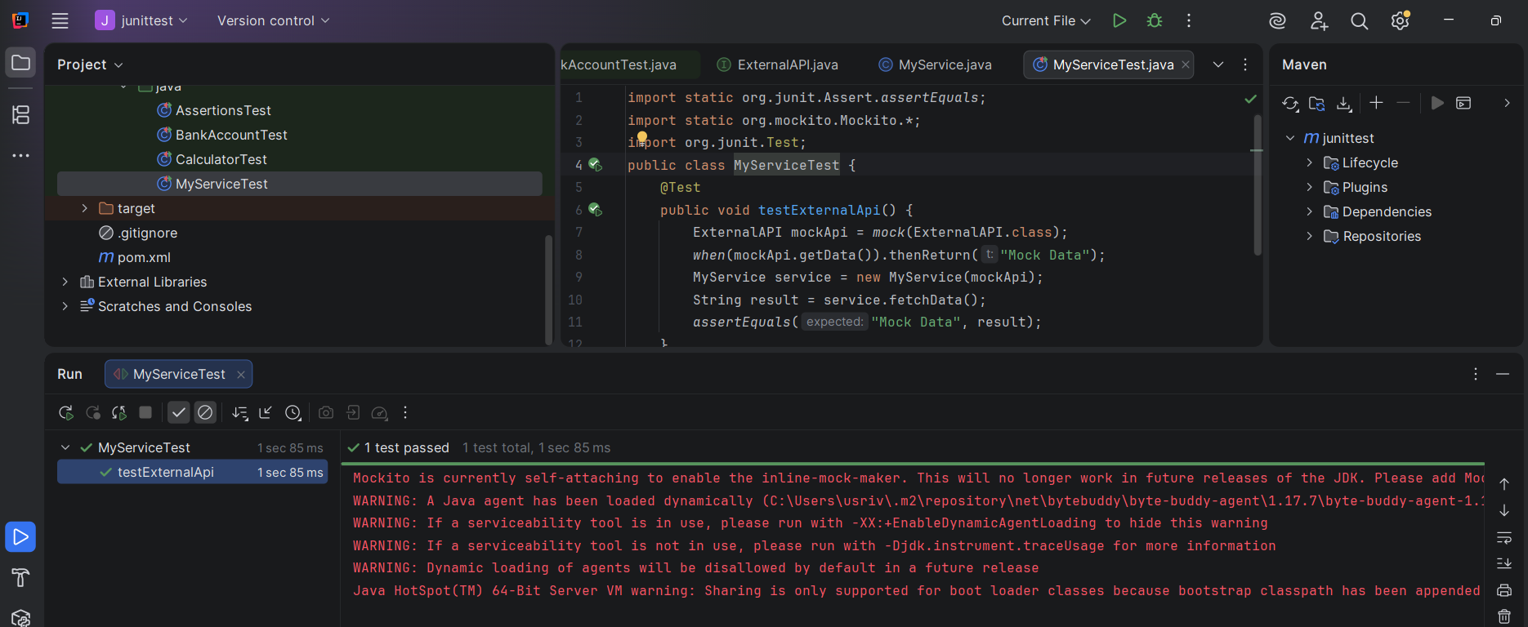

EXERCISE 2: VERIFYING INTERACTIONS

Scenario: You need to ensure that a method is called with specific arguments.

Steps:
1. Create a mock object of the external API.
2. Inject the mock into the service class.
3. Call the service method.
4. Verify that the external API method was called.

Solution Code:
package com.example;
import static org.mockito.Mockito.*;
import org.junit.Test;
public class MyServiceTest {
@Test
public void testVerifyInteraction() {
ExternalApi mockApi = mock(ExternalApi.class);
MyService service = new MyService(mockApi);
service.fetchData();
verify(mockApi).getData();
}
}
OUTPUT :
